**INDIAN INSTITUTE OF TECHNOLOGY . IIT KANPUR**



**ANALYSING HEAT TRANSFER**

**AJAY SINGH (220090)**

**Assignment : 3**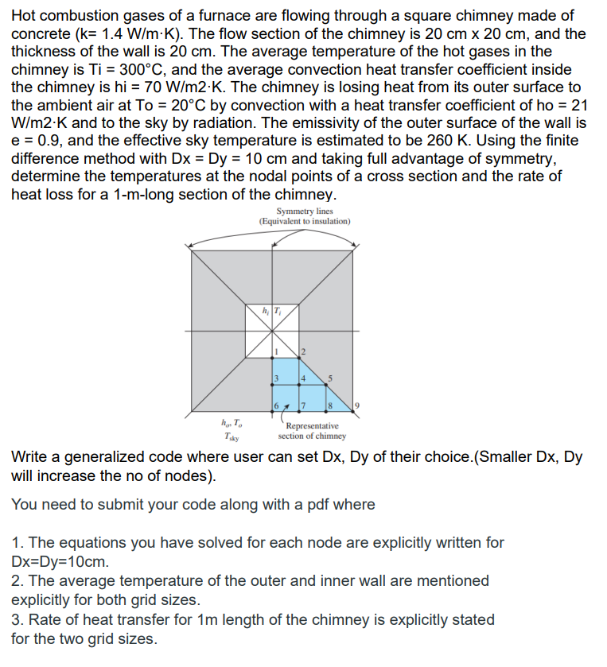

**SOLUTION:**

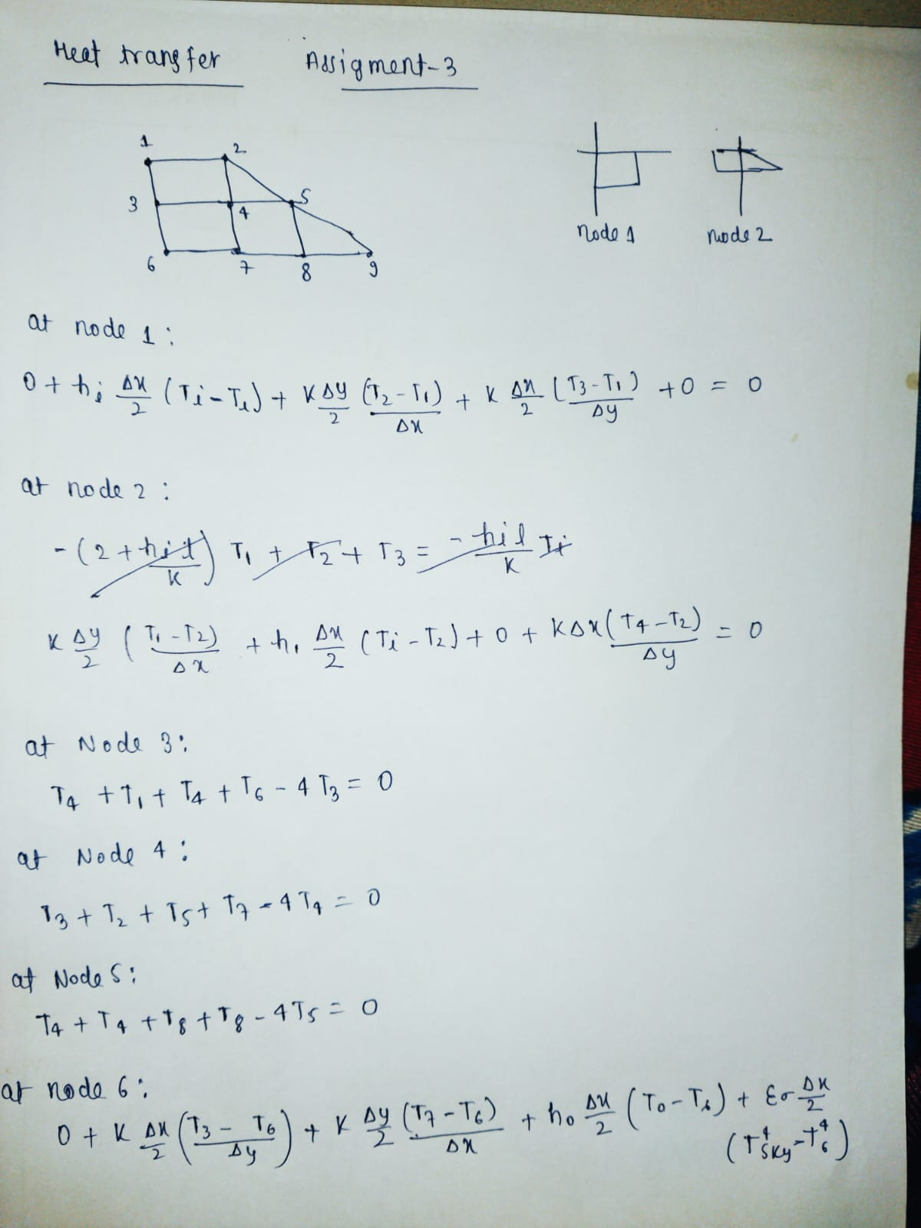

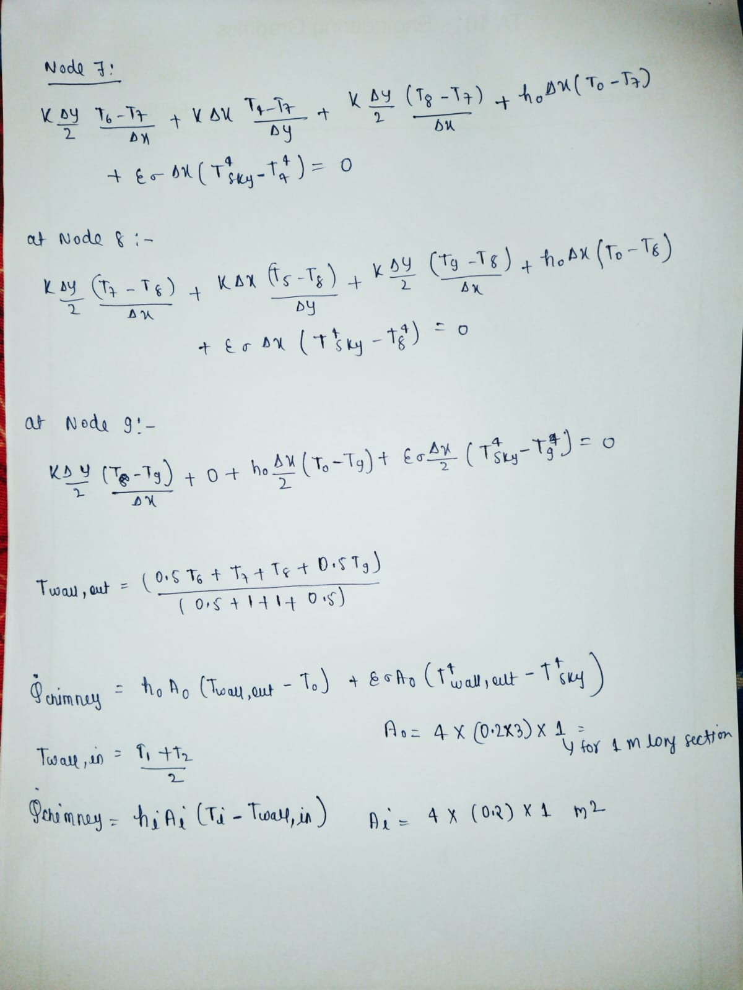

RESULT:  
Temperature at node 1 is 545.5976 K

Temperature at node 2 is 529.0837 K

Temperature at node 3 is 425.0992 K

Temperature at node 4 is 411.0361 K

Temperature at node 5 is 361.9991 K

Temperature at node 6 is 332.7271 K

Temperature at node 7 is 327.9624 K

Temperature at node 8 is 312.9621 K

Temperature at node 9 is 296.3952 K

heat transfer rate of chimney through method 1 is: 1985.516583 W

heat transfer rate of chimney through method 2 is: 1996.924009 W

CODE (Q vs R):

% Given data

Ti = 300 + 273; % Average temperature of hot gases in the chimney (K)

To = 20 + 273; % Ambient temperature (K)

Tsky = 260; % Effective sky temperature (K)

Dx = 0.1;

Dy = 0.1;

k = 1.4; % Thermal conductivity of concrete (W/m·K)

hi = 70; % Convection heat transfer coefficient inside chimney (W/m^2·K)

ho = 21; % Convection heat transfer coefficient outside chimney (W/m^2·K)

e = 0.9; % Emissivity of outer surface

sigma = 5.67e-8;

% enter the value for Dx

%Dx= input('Enter the value for Dx: ');

% enter the value for Dy

%Dy= input('Enter the value for Dy: ');

% Initial guess for the temperatures

initial_guess = 273 * ones(1, 9); % All temperatures start at 273 K

% Define the system of equations

fun = @(T) [

(hi * (Dx/2) * (Ti) + k * (Dy/2) * (T(2) - T(1))/Dx + k * (Dx/2) * (T(3) - T(1))/Dy)/(hi * (Dx/2)) - T(1);

(k * (Dy/2) * (T(1))/Dx + hi * (Dx/2) * (Ti - T(2)) + 0 + k * (Dx) * (T(4) - T(2))/Dy) * Dx/(k * (Dy/2)) - T(2);

(T(4) + T(1) + T(4) + T(6)) / 4 - T(3);

(T(3) + T(2) + T(5) + T(7)) / 4 - T(4);

(T(4) + T(4) + T(8) + T(8)) / 4 - T(5);

(0 + k * (Dx/2) * (T(3) - T(6))/Dy + k * (Dy/2) * (T(7))/Dx + ho * (Dx/2) * (To - T(6)) + e * sigma * (Dx/2) * ((Tsky)^4 - (T(6))^4)) * Dx/(k * (Dy/2)) - T(6);

(k * (Dx) * (T(4) - T(7))/Dy + k * (Dy/2) * (T(6))/Dx + k * (Dy/2) * (T(8) - T(7))/Dx + ho * (Dx) * (To - T(7)) + e * sigma * (Dx) * ((Tsky)^4 - (T(7))^4)) * Dx/(k * (Dy/2)) - T(7);

(k * (Dx) * (T(5) - T(8))/Dy + k * (Dy/2) * (T(7))/Dx + k * (Dy/2) * (T(9) - T(8))/Dx + ho * (Dx) * (To - T(8)) + e * sigma * (Dx) * ((Tsky)^4 - (T(8))^4)) * Dx/(k * (Dy/2)) - T(8);

(0 + k * (Dy/2) * (T(8))/Dx + ho * (Dx/2) * (To - T(9)) + e * sigma * (Dx/2) * ((Tsky)^4 - (T(9))^4)) * Dx/(k * (Dy/2)) - T(9);

];

% Solve the system of equations

options = optimoptions('fsolve', 'Display', 'iter');

temperatures = fsolve(fun, initial_guess, options);

disp('Temperatures at each node:');

disp(temperatures);

T=temperatures;

Twall_out=(0.5*T(6)+T(7)+T(8)+0.5*T(9))/(0.5+1+1+0.5);

Twall_in=(T(1)+T(2))/2;

Ao=4*0.6;

Ai=4*0.2;

Qchimney1=ho*Ao*(Twall_out-To)+e*sigma*Ao*((Twall_out)^4-(Tsky)^4);

Qchimney2=hi*Ai*(Ti-Twall_in);

for i = 1:numel(T)

fprintf('Temperature at node %d is %.4f K\n', i, temperatures(i));

end

fprintf('heat transfer rate of chimney through method 1 is: %f W\n', Qchimney1);

fprintf('heat transfer rate of chimney through method 2 is: %f W\n', Qchimney2);